Industrial IoT with Triton Sensors Monitoring using HTTP
Integration guide
Unification Group
April 2023

Contents
Triton Sensor monitoring – Vaping Detection 1
IT Requirements 2
Instructions 2
1. GENETEC CONFIG TOOL – Industrial IoT plugin configuration 2
a) Create an Industrial IoT plugin instance 2
b) Create and configure an HTTP connector 3
2. GENETEC CONFIG TOOL – Configuration devices from device type 4
a) Import the preconfigured device type 4
b) Adjust imported rule 5
c) Create a device using the Device type 6
3. GENETEC CONFIG TOOL – Assigning Camera 7
a) Adding a camera to the Triton Device (Detector) 7
4. TRITON SYNC configuration 8
Operations 9
Monitoring Maps 9
Reporting 9
Dashboard 10

Integration guide for Triton Sensors system with Industrial IoT plug-in
  - Introduction
The Triton Sensors can be integrated into Genetec Security Center Video Management Software. This integration requires the Genetec Industrial IoT plugin to be installed and licensed. See Genetec Industrial IoT Plugin Guide 5.0.2 for installation and setup instructions.
The Industrial IoT plugin allows data transmission to Security Center through different transmission protocols. In this guide, data is sent from the Triton Sensors system to Security Center through Hypertext Transfer Protocol (HTTP).
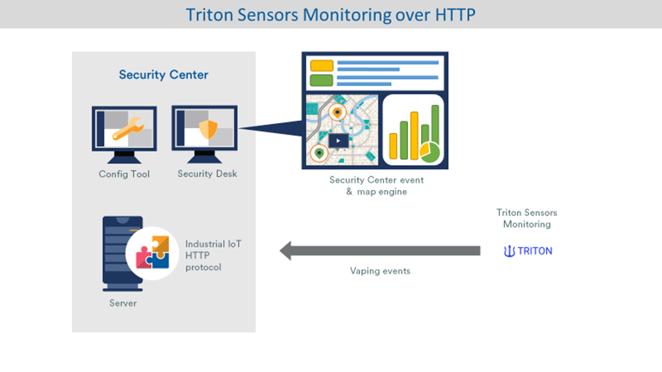
Figure 1
Note: This integration was tested using version 5.11.1 of Genetec Security Center and IIoT 5.0.2.

Triton Sensor monitoring – Vaping Detection
This document describes using Triton sensors to detect vaping and report to Genetec. A camera can be attached to each sensor providing visual verification of the area. This integration will allow to display “Live” and “Playback” video related to each vaping detection. We can display live status of sensor on map, provide report and dashboard with graphical representation of events over time.

IT Requirements
- Open IP port 56789 and forward to IIoT server
- Make sure Triton Sensors system can reach IIoT server (Public/Private IP address)

Instructions

GENETEC CONFIG TOOL – Industrial IoT plugin configuration

Create an Industrial IoT plugin instance
- Log on Config Tool using your administrator credentials.
- In the Tasks tab, in the Administration section, click on the Plugins icon.
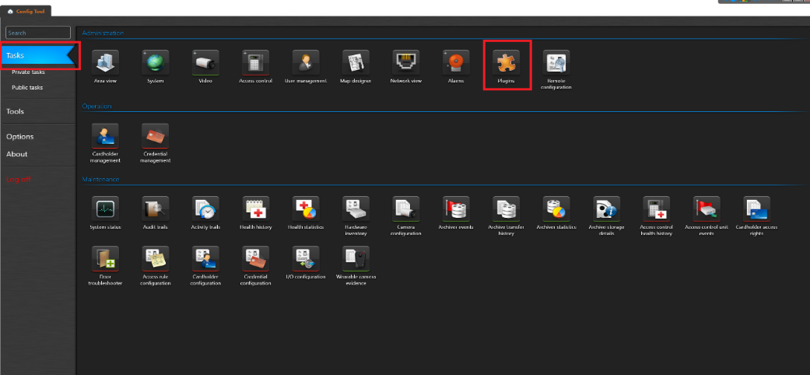
Figure 2
- In the plugins tab, click on the green plus button at the bottom left of the screen and select the Plugin option.
- In the pop-up window, select the Industrial IoT plugin type. The Database server field and database field should be filled in by default. You can rename the plugin in the Basic Information tab if needed. Otherwise just click Next and finish creating the role.
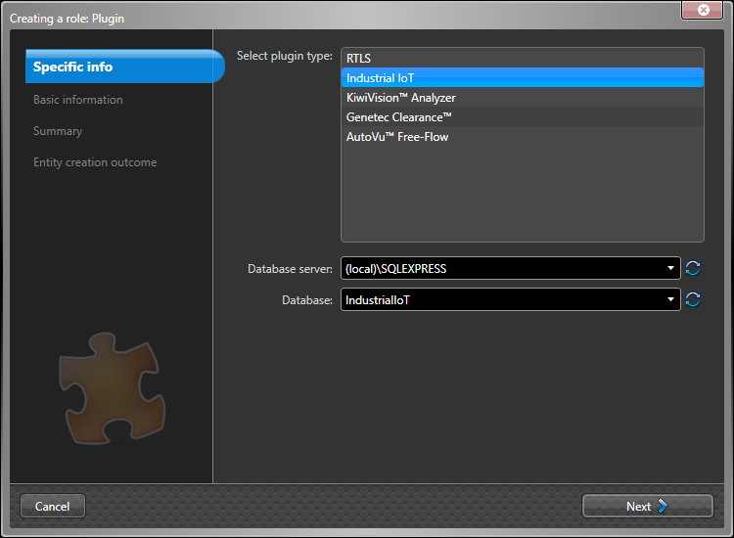
Figure 3

Create and configure an HTTP connector
- Select your plugin instance in the tab on the left-hand side of the screen.
- Select the Protocols tab.
- Select HTTP Server
- Click on the green plus button at the bottom of the HTTP connectors box to add an HTTP connector.
- In the Name text field, enter a name for the connector (In this example, it is Triton).
- Click the Copy to clipboard to copy the API key.
Note: The API key cannot be recovered afterward and will need to be provided to Triton.

- Click the Add button.
- Click on the Apply button at the bottom right of the screen.
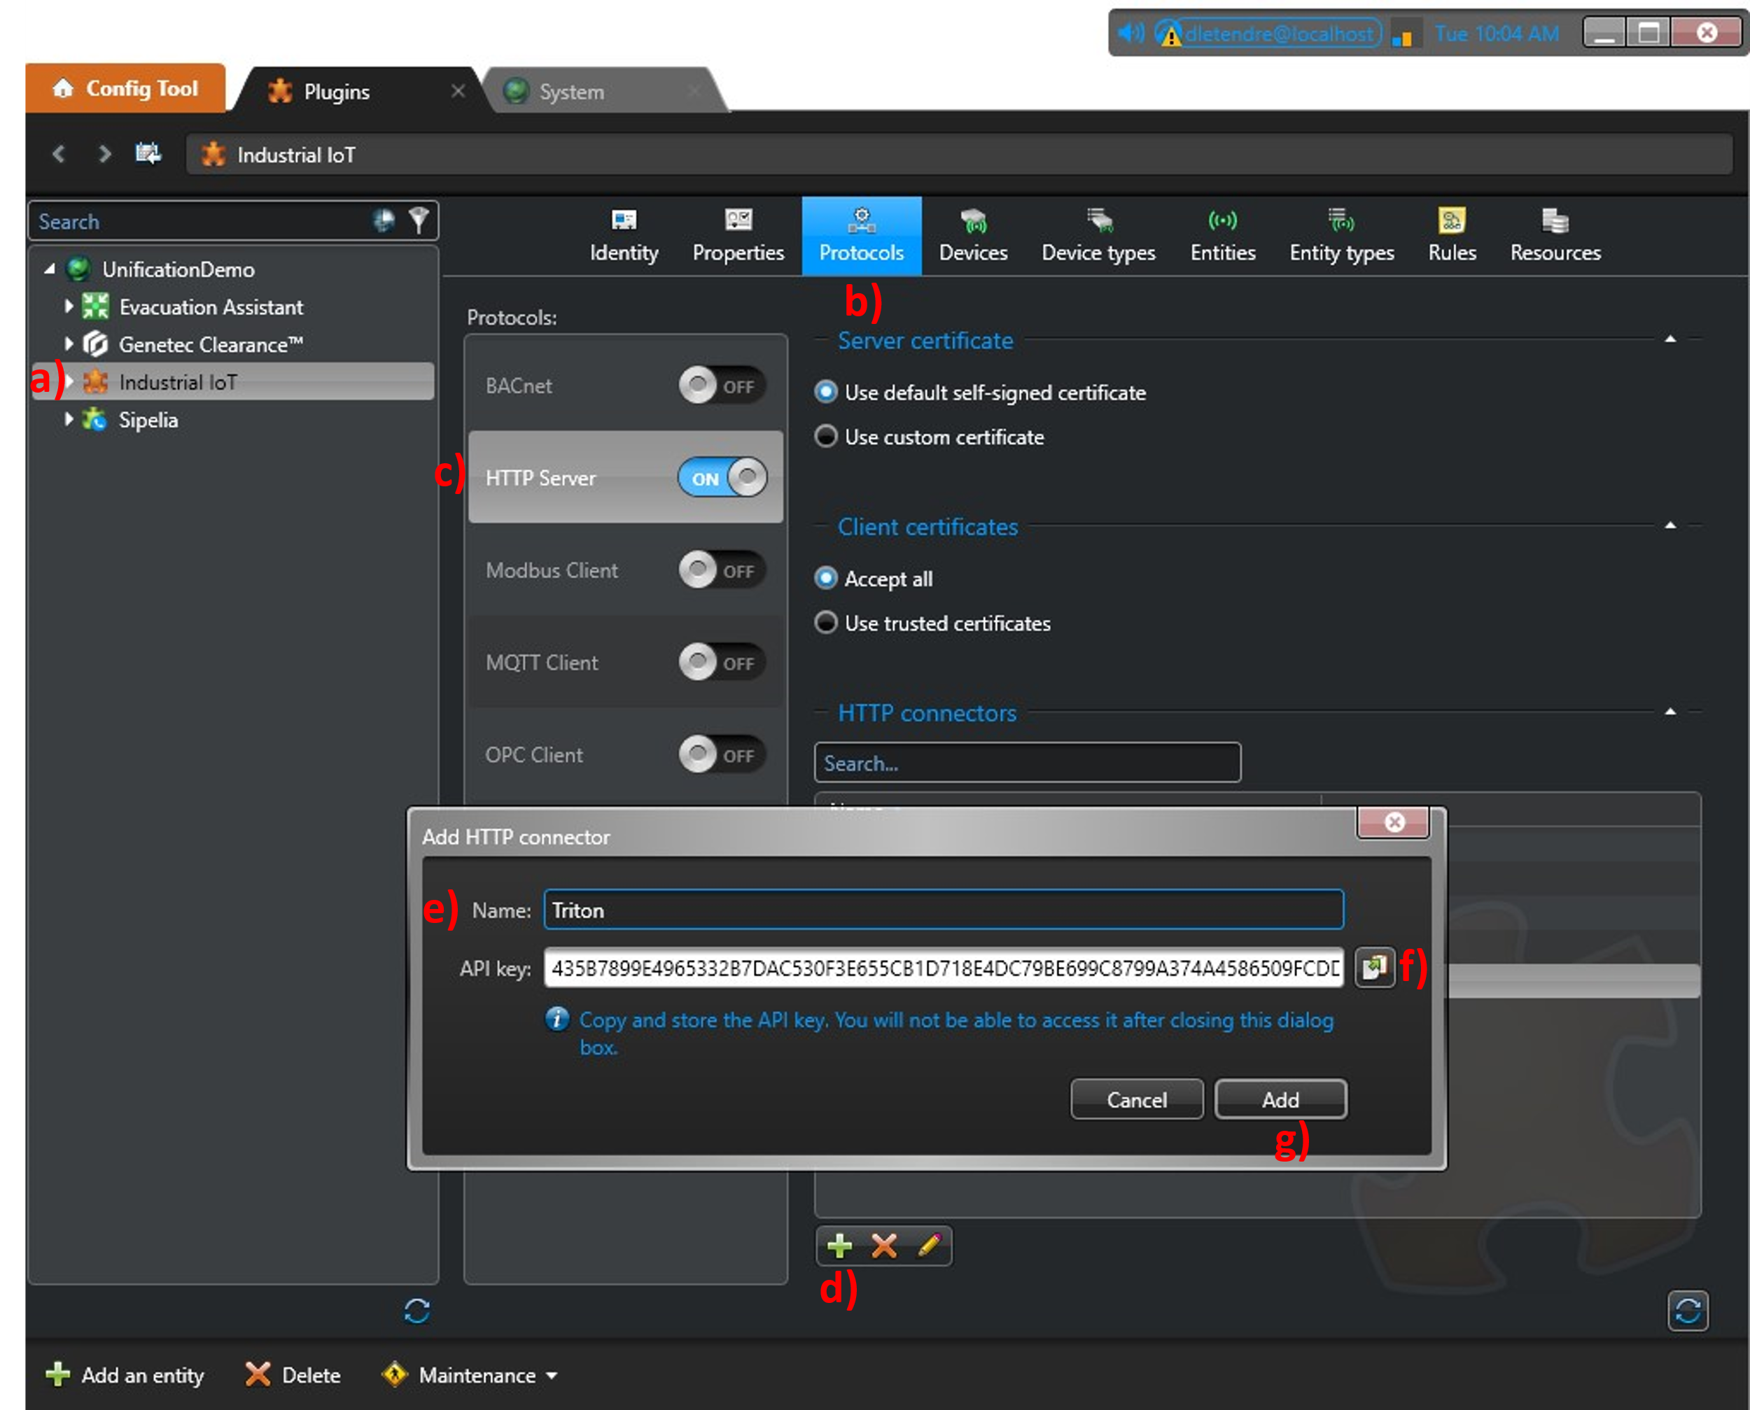
Figure 4

GENETEC CONFIG TOOL – Configuration devices from device type
Version 5.0.2 of the Industrial IoT plugin comes with predefined type that can be easily imported. It is possible to import and export configuration pre-sets for a device type through JSON files. These settings can include data point, event, custom state configurations and rules configured with that device type.
Note: When a device type is imported, its rules will create a warning on the Industrial IoT plugin. The reason this happens is because the alarm and event fields of each rule will be empty. The rules therefore need to be linked to the alarms and events of your choice for the warning to disappear.

Import the preconfigured device type
- Open the Config Tool app and login with administrator credentials.
- Click on the Plugins task.
- Select the Industrial IoT plugin instance on the left-hand side of the screen.
- Click on the Device types tab.
- Click on import, select HTTP_Triton_Device_Type_V5_0_2.json file, and click Open.
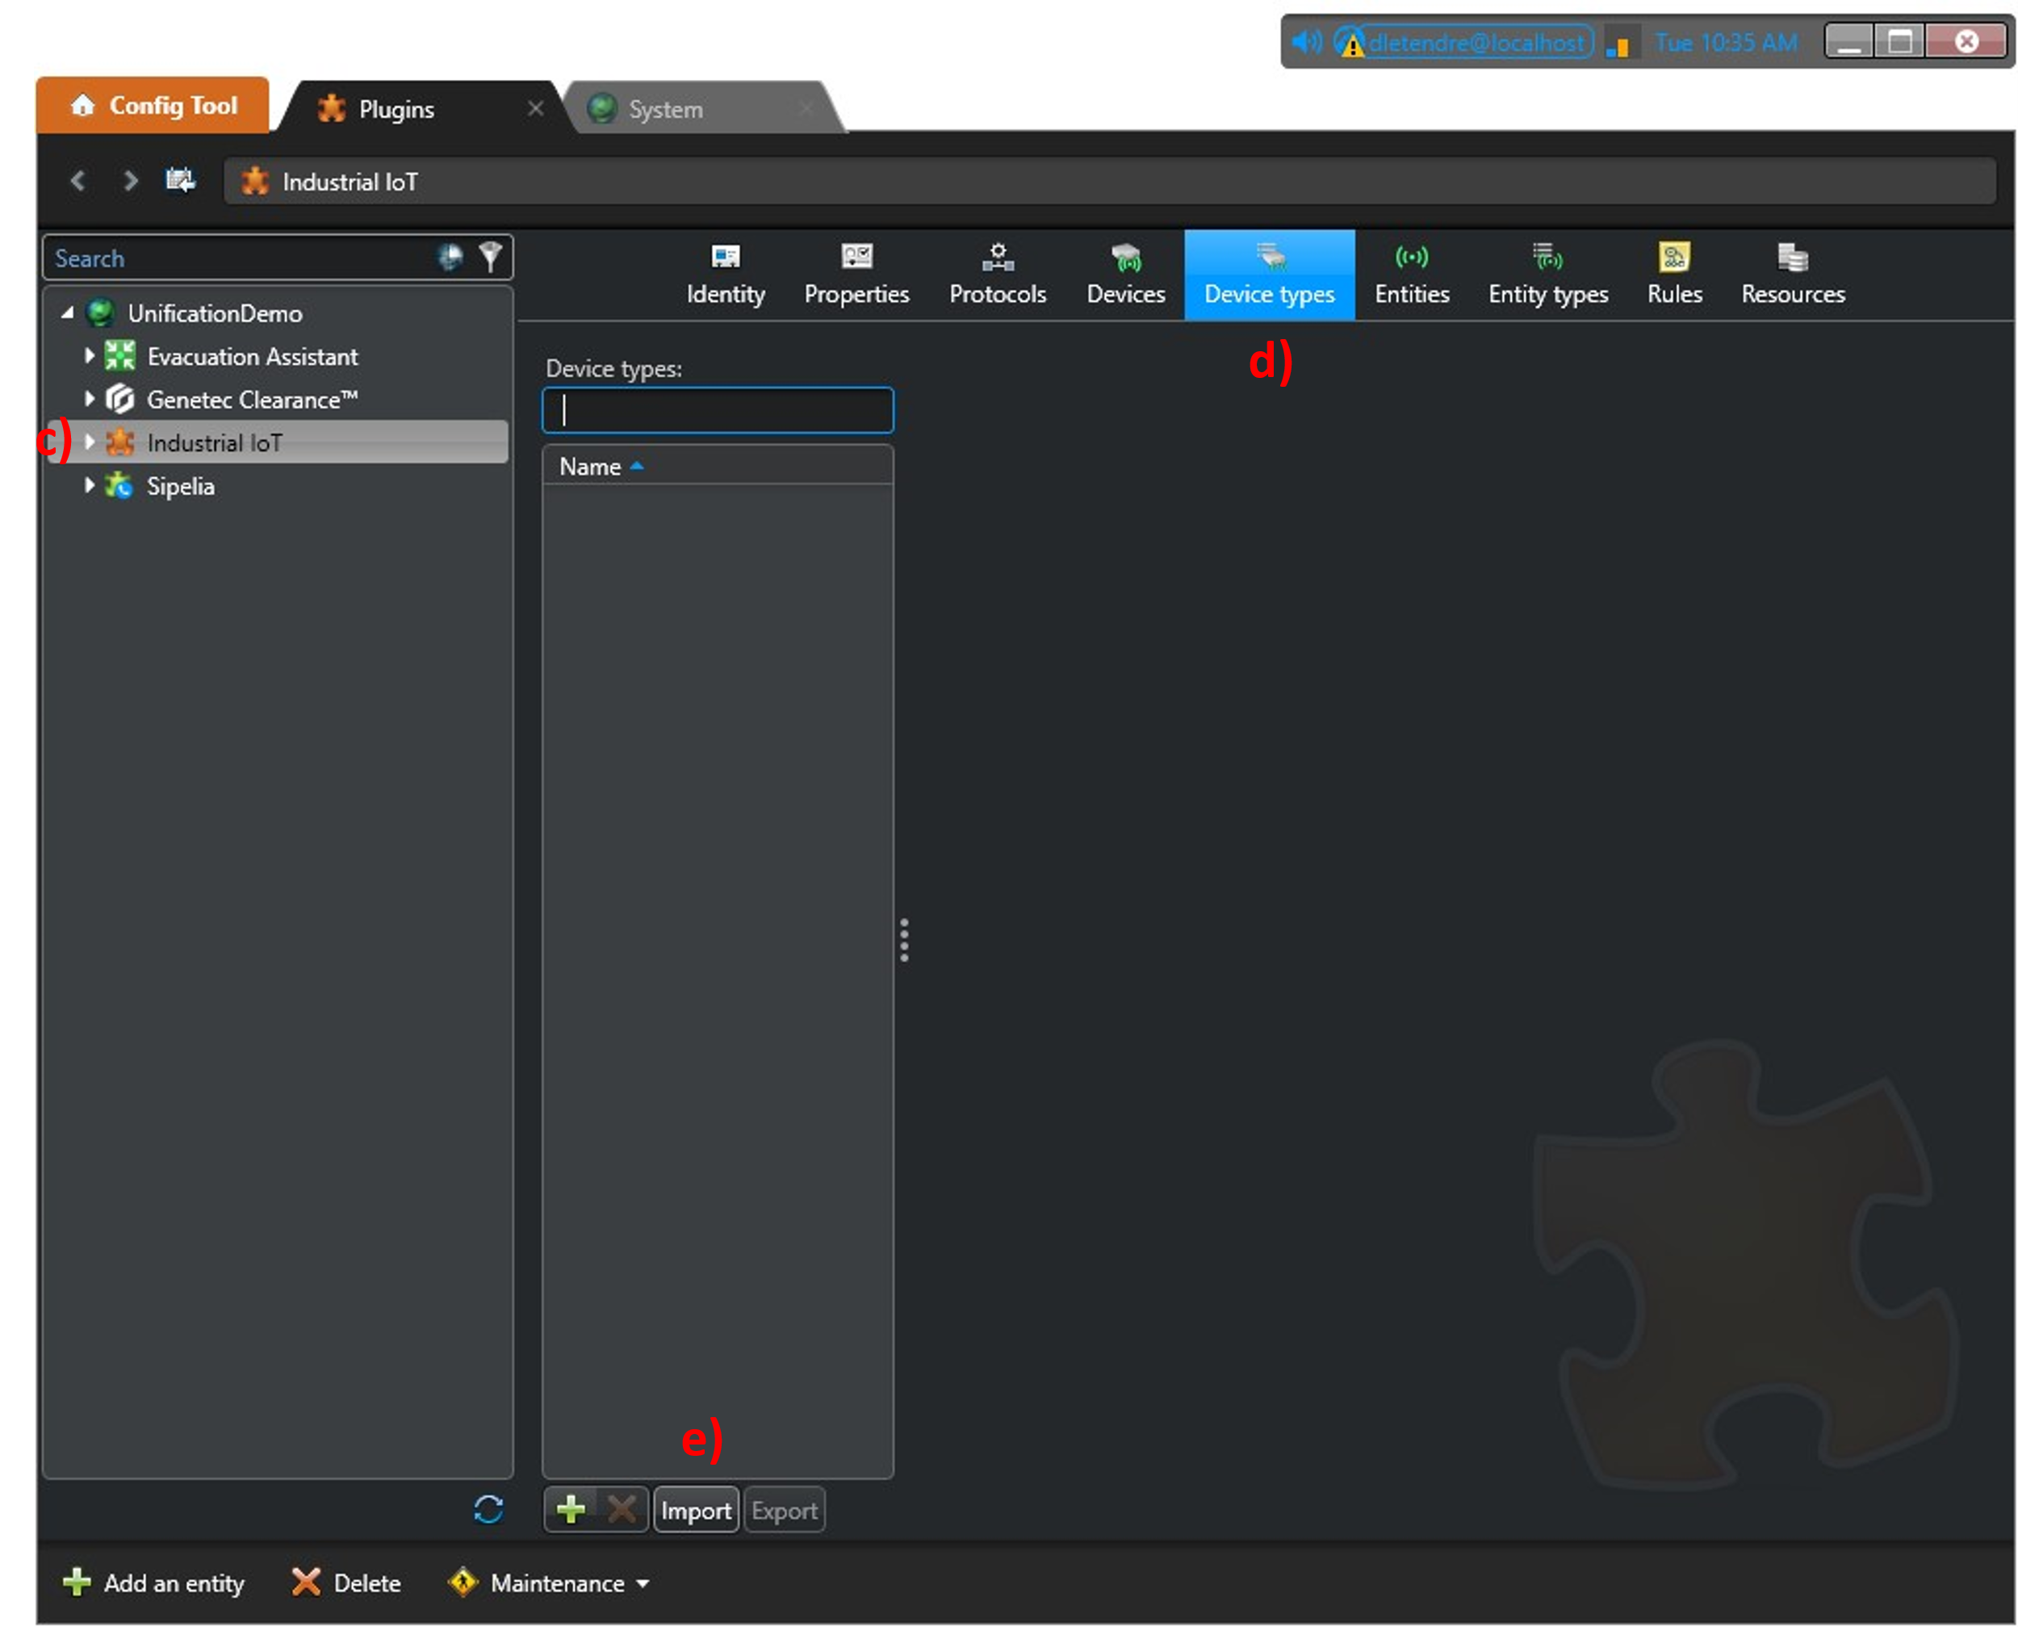
Figure 5

- Click OK.
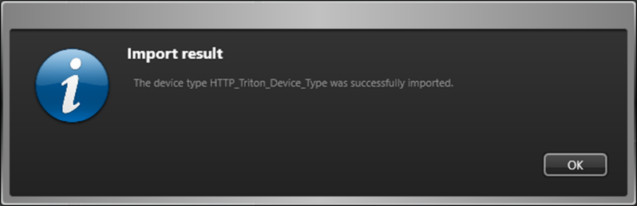
Figure 6

Adjust imported rule
As mentioned previously, the Industrial IoT will generate “Warnings” as imported rules will need to be re-attached to events and alarms present in your system. First you need to define the required custom event and alarms. In this example, 1 event and 1 alarm are used.
- Access the Rules tab. Rules with a “Warning” condition will appear in yellow color.
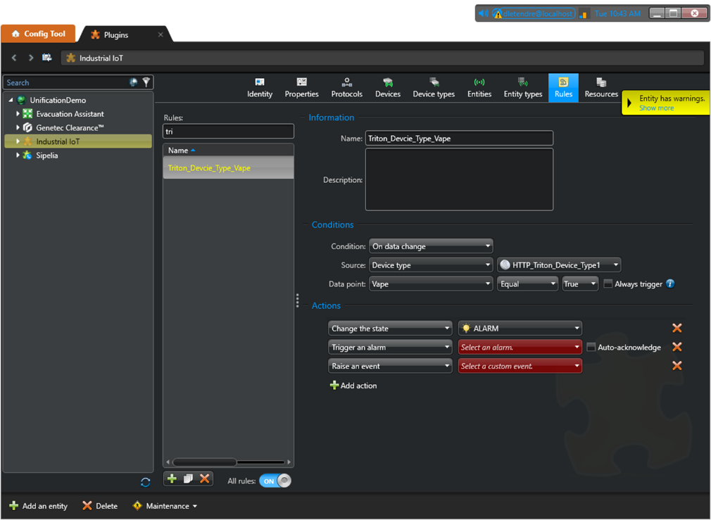
Figure 7
- Select the rule and assign the appropriate alarm and event.
- Click Apply.
- Once completed, the adjusted rule will turn white. When all rules have been adjusted, the “Warning” will disappear.
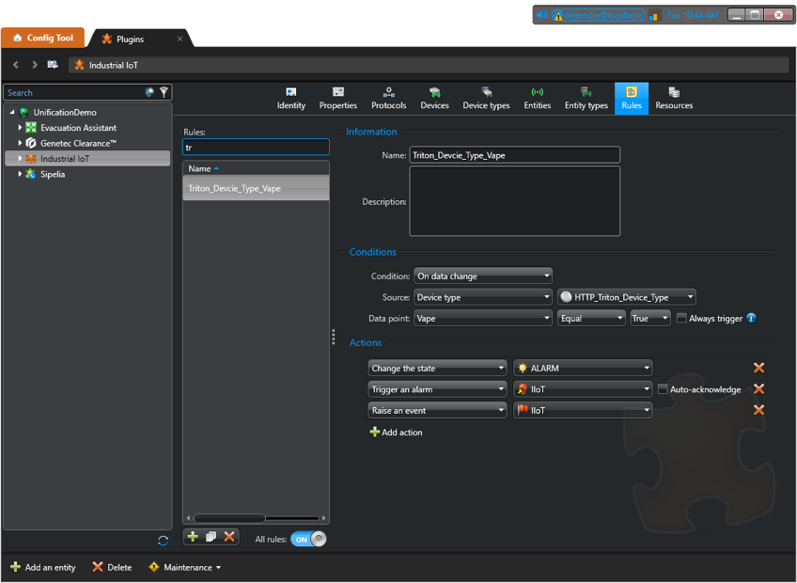
Figure 8

Create a device using the Device type
- Select the Devices tab.
- Click on the green plus button at the bottom of the screen to add a device.
- In the Name text field, enter a name for the device (In this example, it is “Triton1”). We recommend using the same name as in Triton sync for easier referencing.
- The Type field select HTTP_Triton_Device_Type.
- In the Protocol field, select HTTP Server.
- The HTTP connector field should appear. Select the connector that was previously created (in this example, it is “Triton”).
- The Device ID field should appear. The Device ID will be used as the unique identifier for this integration. It will be the MAC address of the Triton sensor. Enter your device MAC address as it appears under Device ID in Triton sync.
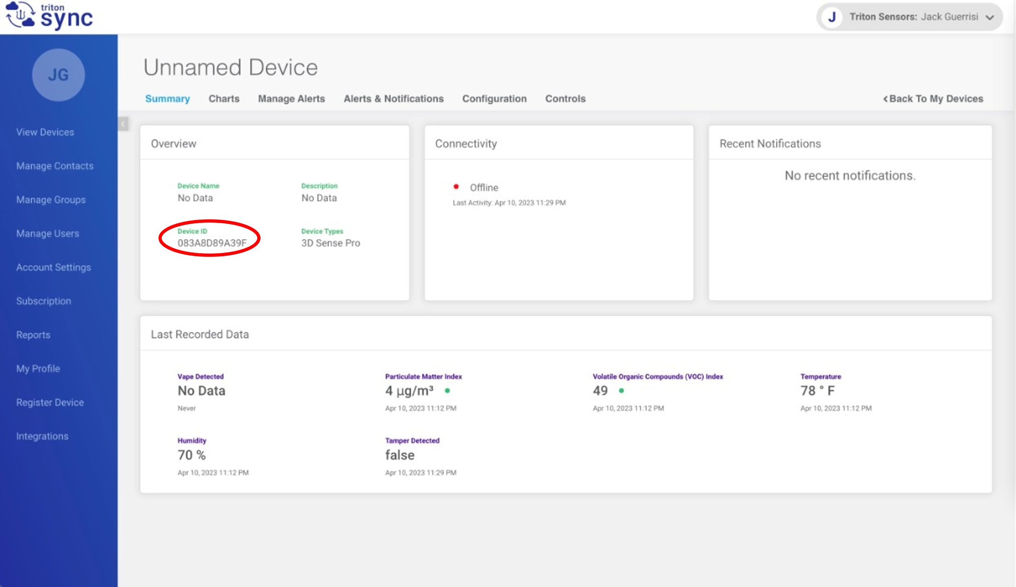
Figure 9
- Click on the Add button.
- Click on the Apply button at the bottom right of the screen.
The device is now created and can be selected under the instance of Industrial IoT on the left-hand side of the screen.
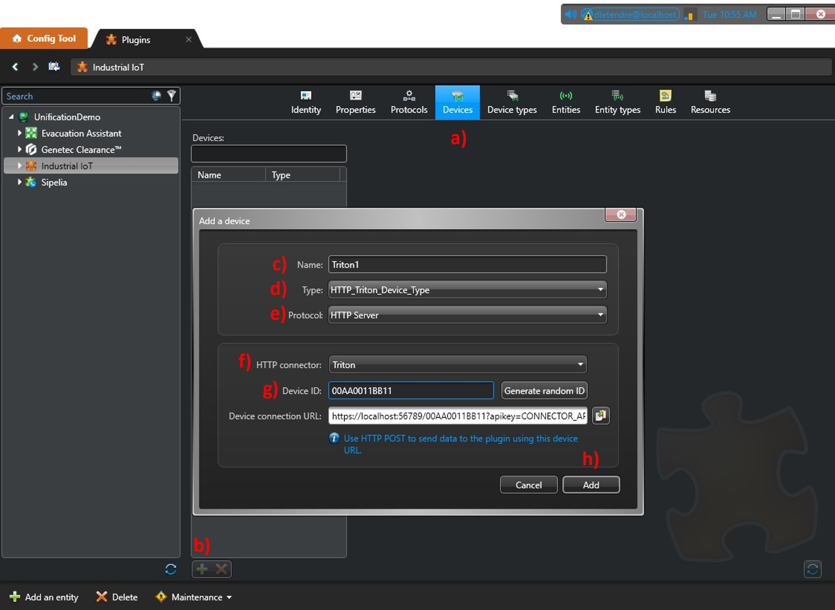
Figure 10

GENETEC CONFIG TOOL – Assigning Camera

Adding a camera to the Triton Device (Detector)
- Select the appropriate device in the tree view in the left section.
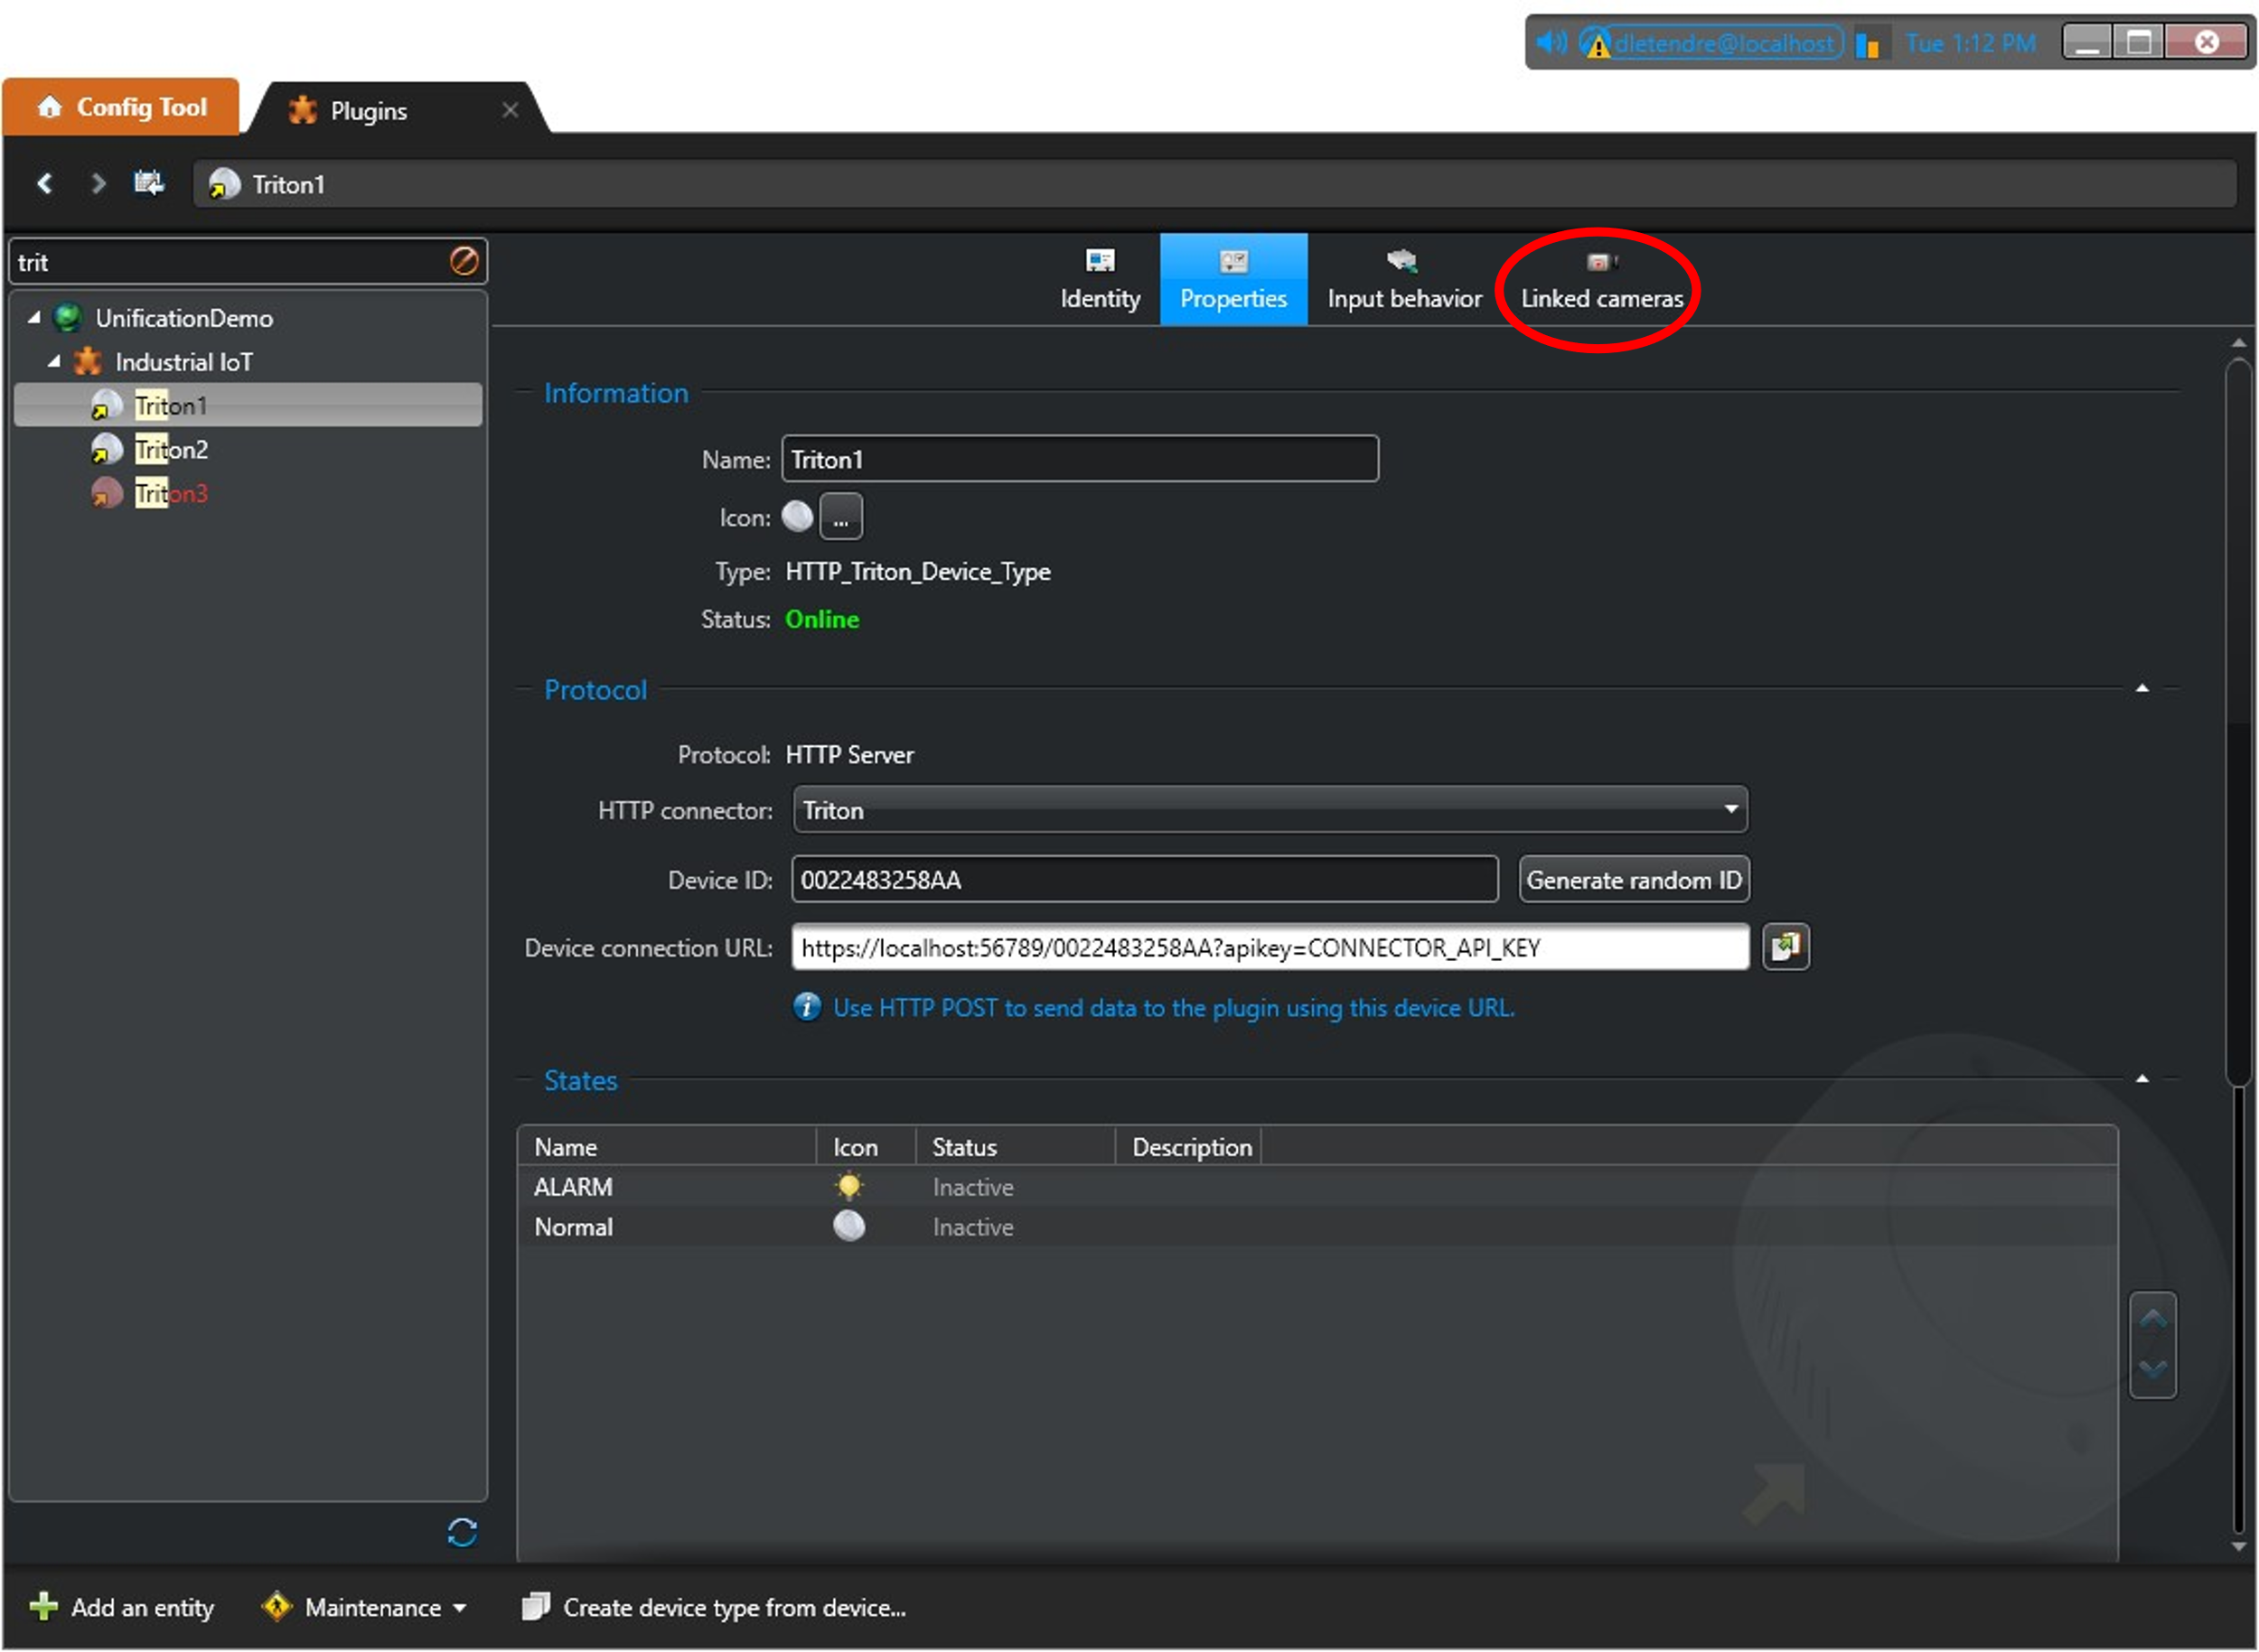
Figure 11
- Click the Linked cameras icon.
- Click on the green plus button at the bottom of the screen to add a camera.
- Select the appropriate camera and click OK.
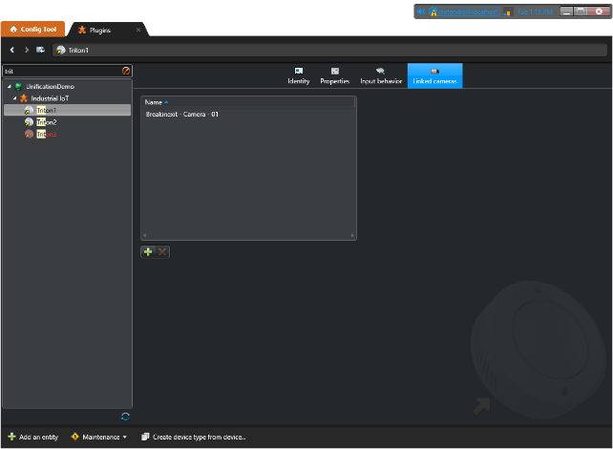
Figure 12

TRITON SYNC configuration
You will need to provide the IP to reach the Industrial IoT plugin server, the port, and the API key (noted in step 1.2).

  - Access your Triton Sync portal page.
Your account type should be administrator to be able to access the Integration tab.
  - Access the Integrations page.
  - Enter the IP address to reach the Industrial IoT server in the IP Address field.
  - Enter 56789 (or the appropriate port if required) in the Port field.
  - Enter the API Key in the API Key field.
  - Click Save
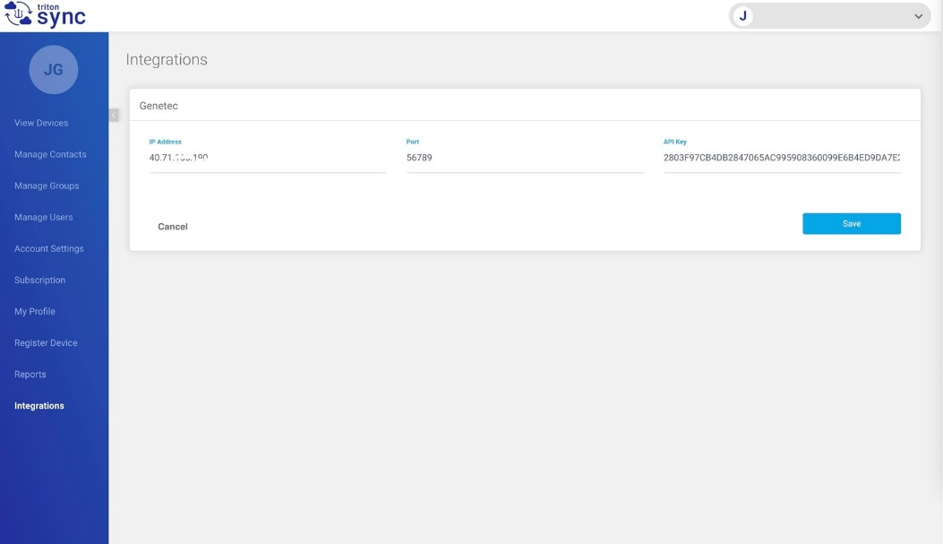
Figure 13

Operations

Monitoring Maps
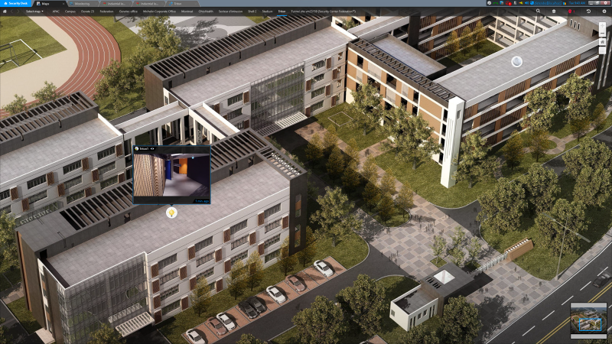
Figure 14

Reporting
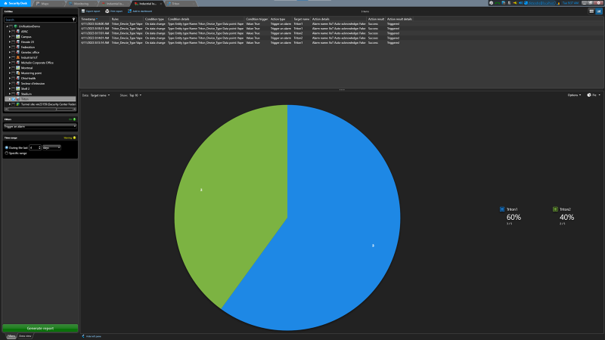
Figure 15

Dashboard
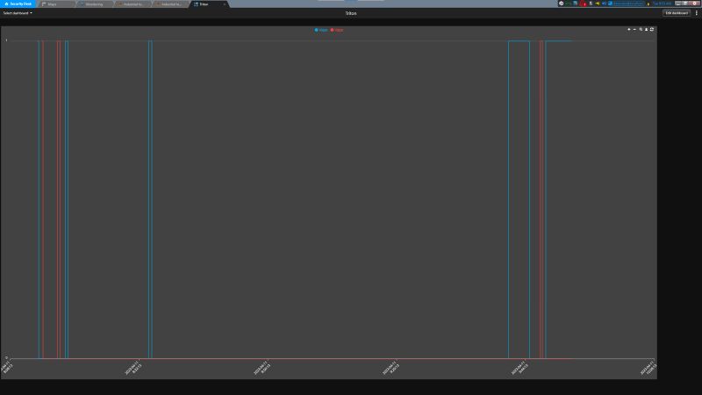
Figure 16

